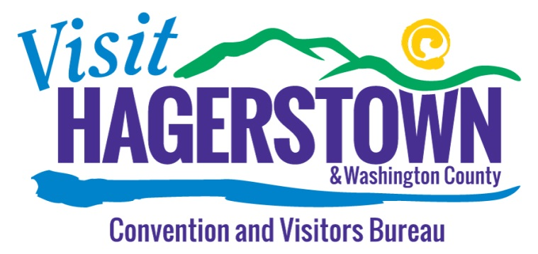

**MEETING of the BOARD OF DIRECTORS**

**AGENDA**

Courtyard by Marriott

January 26, 2017

9:00am

Call to Order D. Spedden

Roll Call J. Thomas

Approval of Minutes D. Spedden

Financial Report D. Spedden

Executive Committee

New Business D. Spedden

Q&A with Staff Staff

Adjournment D. Spedden

Next Board Meeting: March 30, 2017

The Mission of the Bureau shall be to promote Hagerstown and Washington County by increasing tourism and visitor spending through the marketing and promotion of attractions, events, accommodations and visitor services which will contribute to economic development.